SMS Workflow

1. Create Local Template for JBL.SMS.PARAMETER, and JBL.SMS.BOOK.
2. Write a authorize routine for version (Transactional), which functionalities is: -
   1. Read SMS parameter from the Parameter Table.
   2. Store the Phone No, Email, Priority and SMS body to SMS Book table.
3. Write an API routine for AA. Which functionalities is: -
   1. Trigger based on activity authorize.
   2. Build SMS body according to SMS Parameter Table.
   3. Store SMS body and Phone no, email, priority and SMS body to SMS Book table.
4. Write a service routine which functionalities is: -
   1. Pick SMS body and Phone No, email, and API Link from SMS Book table.
   2. Consume SMS API provided by Bank.
   3. Update the SMS status after consuming service successfully.
5. Moved SMS.BOOK data to history

Sample Parameter setup for new account sms.

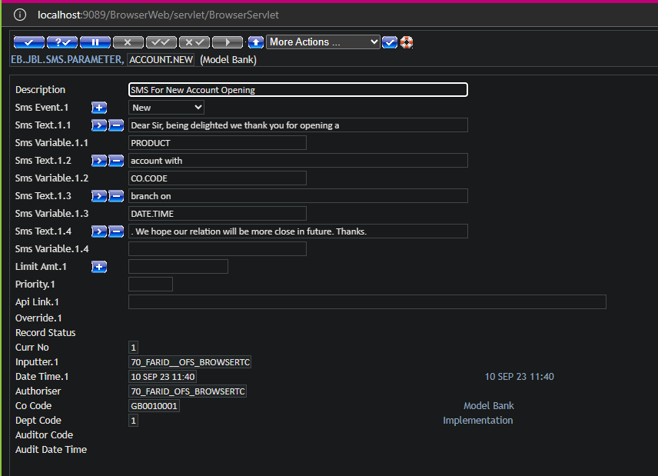

SMS BOOK TABLE: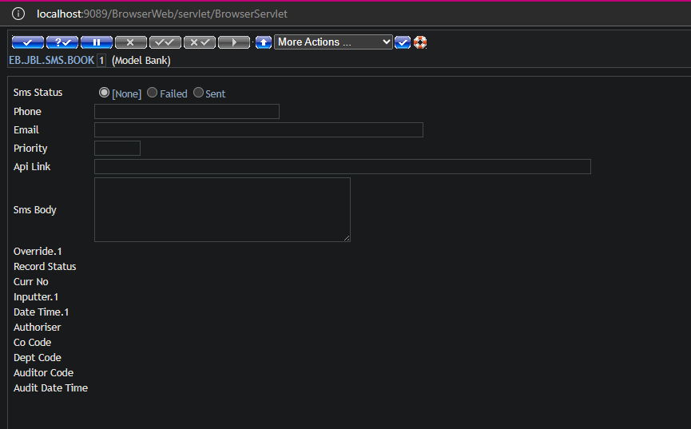

NB:

1. For transactional parameter Id would be version name if version id not exist then by default application. Done
2. For Arrangement account parameter id should be activity id. Done
3. For others id would be application name. Done
4. For On demand separate template should maintain (EB.JBL.SMS.ON.DEMAND) and ID must be ‘SYSTEM’. For English SMS body will be in template. For Bangla SMS body will store in flat file in app-server physical fixed location. SMS body read from the flat file in selection routine. Done
5. Folder and file name would be fixed, and folder location must be under UD. Done
6. SMS Body also need to be built if email id exists on customer as mobile no. Done